Research on magic-time theme:
The passage of time is a mystical thing. These spells work to speed or slow time for yourself.
If you want time to go by more quickly, then cast the speed time spell. What this spell does is slows down the passage of time in a small area around yourself, thus making the rest of the world appear to go by faster.
This is a difficult concept to understand, but think of it like this. A minute is a minute is a minute. So in order to speed up time for you, a real minute must seem like 30 seconds to yourself. So time around you slows so that while the rest of the world lives for 60 seconds, you only live through 30 seconds, and time appears to go twice as fast.

Chronokinesis
This is a technique to slow time. Not time travel or stop time. No one ever done that before unless its in dream or what they call as astral.
Freeze Time
Take the 5 green used candles and pick off the melted wax (WARNING: MAKE SURE YOU DO NOT USE CANDLES THAT HAVE JUST BEEN LIGHTED). Place the wax in the small bowl and mix with water. Repeat the following while mixing:
Brain Freeze,
Water Freeze,
Time Freeze!
Slow Down Time
- Look at you watch and imagine that every second on the watch is actually 2 seconds
2. Now move in slow motion and say: "Go Flow, Slow Mo!" Repeat until your watch goes slow (or you go slow motion)

Merlin the Magician’s powers according to Arthur Legends:

Merlin had many superhuman powers, most of which have yet to be revealed. He could rearrange the molecular structure of objects and teleport objects and living beings through dimensions. He could also alter his appearance, although whether he actually physically transformed himself or merely cast illusions to make himself look different is unknown. Presumably this Merlin's powers were psionic in nature, but if he was indeed the same being as the wizard of Camelot, then presumably many of his powers were actually magical.
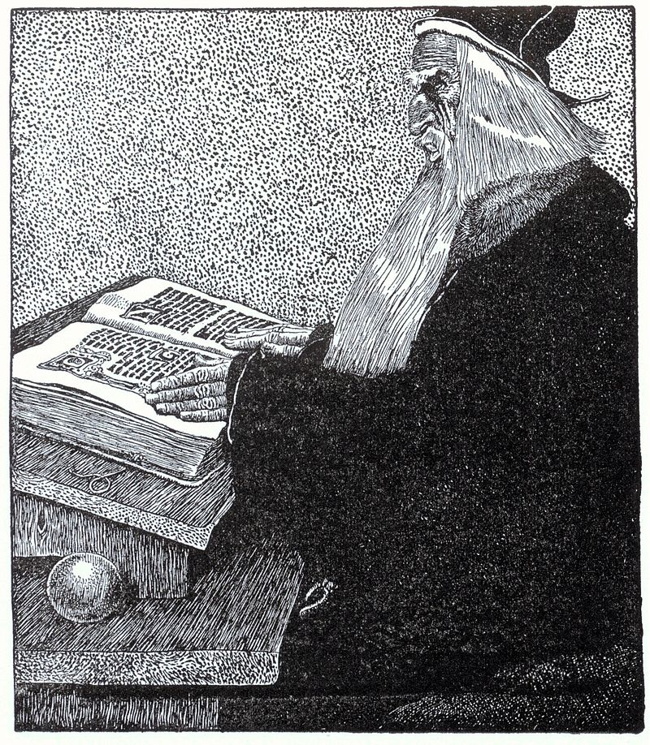
Useful material:
When he arrived in Middle Earth, he received Narya, the ring of fire, from Cirdan the Shipwright.The Dwarf king entrusted Gandalf with a map to Erebor. As Dol Guldur had once been one of Sauron’s strongholds Gandalf feared that Sauron’s agents were at large again.

